Unveiling the Secrets: Exploring the Impact of Operating Systems on Redis Performance in Windows and Ubuntu Environments

20IT007 Dev Bhavsar   
*Department of Information Technology  
C S Patel Institute of Technology, CHARUSAT*Changa, India [20it007@charusat.edu.in](mailto:20it007@charusat.edu.in)

20IT094 Het Patel   
*Department of Information Technology  
C S Patel Institute of Technology, CHARUSAT*Changa, India [20it094@charusat.edu.in](mailto:20it094@charusat.edu.in)

*Abstract -* Redis is a widely used in-memory database which is known for its high-performance data processing and low latency. However, there is limited research comparing the performance of Redis on different operating systems. This study aims to analyze and compare the performance of Redis on Windows and ubuntu operating systems, as well as compared the ext4 and XFS file systems. Here the throughput is taken as an evaluation metric which indicates response per second. The experimental setup ensures consistency by using the same Redis version across both platforms. Results show that Redis on Windows and Ubuntu, as well as ext4 and XFS file systems run significantly differently, with ubuntu and XFS regularly outperforming windows and ext4 respectively. We investigate various causes of the observed differences, including native support, memory management, file systems and threading/synchronization techniques. Recommendations are given for improving Redis performance on both Windows and Ubuntu in light of the fundings.

# introduction

In-memory databases have become a key element for effective data storage and retrieval in the era of constantly expanding data-driven applications. Due to its outstanding performance and low latency characteristics, Redis, an open-source in-memory data structure store has grown significantly in popularity. Redis is a great option for applications with strict performance needs since it keeps data fully in memory, enabling quick data access and manipulation.

Redis performance, however, can be impacted by a number of variables, including the computer’s operating system that it is running on. Redis is well recognized for running quickly on Linux-based systems like Ubuntu, but nothing is known about how quickly Redis runs on Windows operating systems. This study intends to close this performance gap and explore the variations in Redis performance between Windows and Ubuntu.

E-commerce, real-time analytics, caching, and session management are just a few of the areas where Redis is frequently used. Many developers and organizations like it because of its capacity to manage heavy concurrent workloads, support a variety of data types, and offer powerful caching mechanisms. Selecting the best platform and optimizing Redis deployments to satisfy particular application requirements involves an understanding of the performance differences between Redis on various operating systems.

The observed performance disparities between Redis on Windows and Ubuntu are the central issue of this study. Despite the fact that Redis has demonstrated remarkable performance on Linux-based systems, it is crucial to assess its performance on Windows due to the widespread usage of this platform and the unique requirements of Windows-based applications. Organizations can choose the best operating system for their Redis deployments and optimize performance as a result by recognizing and comprehending performance variances.

# objectives

The primary objectives of this research are as follows:

1. *To compare Redis' performance metrics for response time under Windows and Ubuntu. We want to measure and analyze the performance variations between the two systems through thorough benchmarking studies.*
2. *To determine the causes of the performance discrepancies between Redis on Windows and Ubuntu. This entails a thorough examination of numerous elements, including native support, memory management, file systems, threading/synchronization techniques, and any more pertinent features that might have an impact on Redis speed.*
3. *To suggest possible Redis enhancements for the Windows and Ubuntu operating systems. We intend to provide precise advice and configuration optimizations that can improve the performance of Redis on both platforms based on the findings from the performance comparison and identification of key elements.*

# literature survey

1. *Redis performance and comparisons across various operating systems have been investigated in earlier studies and research articles, offering insightful information on the subject. Still, there are gaps in the literature that this study seeks to fill. The gaps that our research intends to address are highlighted as we evaluate pertinent studies, analyze their findings, techniques, and limitations.*
2. *A notable investigation of Redis performance on Ubuntu and CentOS by X. Zhang et al. (2018) concentrated on the effects of various file systems. The Ext4 file system performed better under Redis workloads than other file systems like XFS and Btrfs, according to extensive benchmarking experiments done for the study. The study emphasized how selecting the right file system is crucial for enhancing Redis performance.*
3. *Redis performance was assessed in a different study by Y. Liu et al. (2019), with a focus on Windows Server environments and both Linux and Windows environments. The study covered the difficulties in enhancing Redis performance on Windows, covering elements like thread management and varying file systems. The study did not, however, directly compare Ubuntu's and Windows' Redis performance.*

# Methodology

**4.1 Hardware and Software Details**

- To ensure transparency and reproducibility, it is important to provide the hardware and software specifications of the machines used in our research. The experiments were conducted on two separate machines, denoted as Machine A and Machine B.

4.1.1 Machine A

- Machine A consisted of robust hardware specifications, featuring an 11th Gen Intel(R) Core(TM) i5-1135G7 processor with 12 cores and a clock speed of 2.4 GHz. It was equipped with 8 GB of DDR4 RAM and utilized a solid-state drive with a storage capacity of 250 GB. The machine ran Windows 11 (version 21H2) as the operating system.

4.1.2 Machine B

- Machine B was equipped with high-performance hardware components, including an 10th Gen Intel(R) Core(TM) i5-1035G1 processor with a clock speed of 1.2 GHz. It had 8 GB of DDR4 RAM and utilized a solid-state drive with a storage capacity of 250 GB. The machine was running Ubuntu 20.04 LTS as the operating system.

**4.2 Setup and Configuration**

- We put up dedicated servers running the Windows and Ubuntu operating systems for the experimental environment. To ensure precise performance assessment and reduce hardware constraints, the servers are outfitted with high-performance hardware.

- To ensure consistency and comparability in the trials, the Windows and Ubuntu systems are both set up with the most recent stable releases of their respective operating systems.

- The Redis in-memory database is set up and installed on each system in accordance with the suggested setup guidelines and best practices listed in the Redis handbook.

**4.3 Redis Version and Additional Software/Tools**

- Redis version 3.0.504 was utilized as the foundation for our experiments. This version provided the necessary features and improvements to investigate the impact of operating systems on Redis performance. It is crucial to utilize the same Redis version on Windows and Ubuntu in order to achieve fair comparisons and get rid of performance differences caused by different versions.

- To create realistic workloads and assess Redis performance in various contexts, we also use benchmarking tools like Redis Benchmark (Redis-benchmark).

**4.4 Data Set and Key Configurations**

- For benchmarking Redis performance, we employed a representative data set consisting of users/customer records. The data set was carefully crafted to simulate real-world scenarios and encompassed various data patterns and sizes. Key configurations, such as key expiration, eviction policies, and data structure-specific configurations, were adjusted to evaluate their impact on Redis performance.

**4.5 Benchmarking Methodology**

- To assess Redis performance on Windows and Ubuntu, the benchmarking approach simulates real-world workloads.

- We create a number of example workloads, including read-intensive, write-intensive, and mixed workloads, to match typical usage scenarios. These workloads simulate genuine application interactions by combining many standard Redis operations, including GET, SET, INCR, DEL, and others.

- To stress test Redis performance on both operating systems, the benchmarking is done by running workloads via the selected benchmarking tool while simulating numerous concurrent clients.

- During the benchmarking process, performance metrics like throughput (requests per second) are measured.

- To achieve reliable and consistent results, the benchmarks are run over multiple iterations, with sufficient warm-up times to stabilize the system prior to data collection.

# Results and analysis:

The outcomes of our benchmarking experiments contrasting Redis' functionality on Windows and Ubuntu are shown in this section. We track different performance measures and analyze the data to pinpoint the major causes of the observed performance gaps.

The rate at which Redis processes requests; often expressed in operations per second (ops/sec) or requests per second (RPS). Better performance and scalability can be found in throughput.

**5.1 Visualizing Performance Differences**

- We show a line graph that shows the throughput rates that Redis on Windows and Ubuntu achieves. This graphic displays any notable variations between the two operating systems' Redis speed and scalability.

|  |  |  |
| --- | --- | --- |
| Request (GET) | Request per second (Ubuntu) | Request per second (Windows) |
| 100 | 33333.33 | 30959.75 |
| 20000 | 52910.05 | 33057.85 |
| 30000 | 78125 | 29556.65 |
| 40000 | 51020.41 | 35242.29 |

**5.1.1 GET operation**

Here we tested for variable number of requests and fixed number of clients (100).

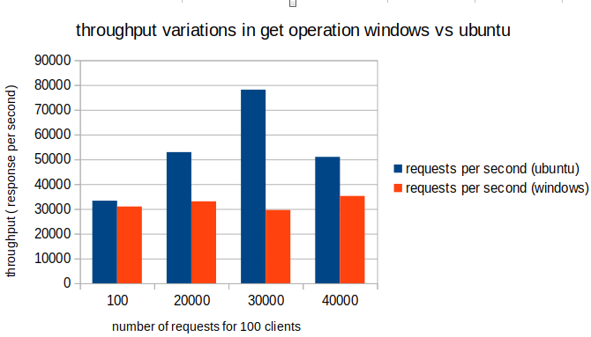

Figure 1: Bar chart for throughput comparison for GET operation between Windows and Ubuntu.

**5.1.2 SET operation**

Here we tested for variable number of clients and fixed number of requests.

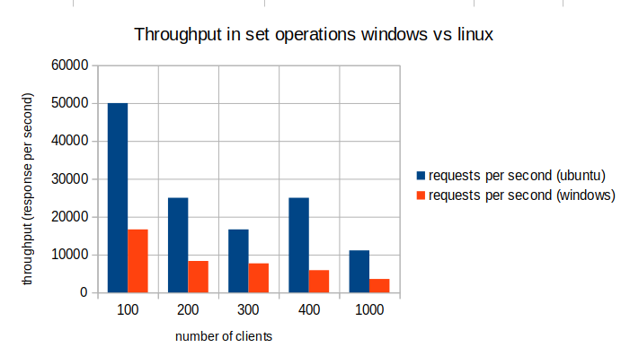

Figure 2: Bar chart for throughput comparison for SET operation between Windows and Ubuntu.

|  |  |  |
| --- | --- | --- |
| Clients (SET) | Requests per second (Ubuntu) | Requests per second (Windows) |
| 100 | 50000 | 16666.67 |
| 200 | 25000 | 8333.33 |
| 300 | 16666.67 | 7692.31 |
| 400 | 25000 | 5882.35 |
| 1000 | 11111.11 | 3571.43 |

**5.2 Analysis of Performance Disparities**

We do a data analysis based on the benchmarking results to pinpoint the main causes of the performance differences between Redis on Windows and Ubuntu. Some potential elements to think about are:

1. Native Support: Redis performance on Windows and Ubuntu may be impacted by differences in native support and optimizations. For instance, the performance of Redis can vary depending on the operating system and the accessibility of particular system libraries or kernel functions.

2. Memory Management: Windows and Ubuntu may use different memory management strategies, which could have an impact on how Redis uses and accesses memory. Performance variances may result from variations in memory allocation, caching techniques, and memory synchronization.

3. File Systems: The performance of Redis may be impacted by the choice of file system on Windows and Ubuntu, such as NTFS and Ext4, respectively. Redis performance as a whole can be affected by variations in file system performance, caching strategies, and file I/O activities.

**5.3 Redis Performance on different File Systems in Linux based Operating System.**

**5.3.1 GET operation**

- Here we tested for variable number of requests and fixed number of clients (100). We show a line graph that shows the throughput rates that Redis on ext4 and xfs file system achieves during the performance of GET operation. This graphic displays any notable variations between the two operating systems' Redis speed and scalability.

|  |  |  |
| --- | --- | --- |
| Request(GET) | Request per second(Ubuntu ext4) | Request per second(Ubuntu xfs) |
| 100 | 33333.3 | 99999.99 |
| 20000 | 52910.05 | 114285.72 |
| 30000 | 78125 | 91743.12 |
| 40000 | 51020.41 | 75046.91 |

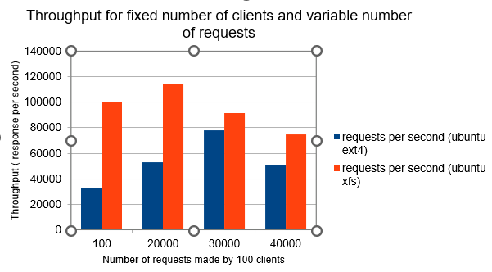

Figure 3: Bar chart for throughput comparison for SET operation between ext4 and xfs file system.

**5.3.2 SET operation**

- Here we tested for variable number of clients and fixed number of requests. We show a line graph that shows the throughput rates that Redis on ext4 and xfs file system achieves during the performance of SET opeation. This graphic displays any notable variations between the two operating systems' Redis speed and scalability.

|  |  |  |
| --- | --- | --- |
| Clients (SET) | Requests per second(Ubuntu ext4) | Requests per second(Ubuntu xfs) |
| 100 | 50000 | 50000 |
| 200 | 25000 | 50000 |
| 300 | 16666.67 | 25000 |
| 400 | 25000 | 16666.67 |
| 1000 | 11111.11 | 9090.91 |

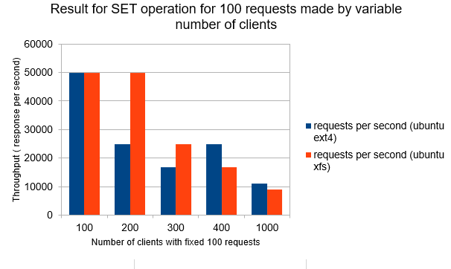

Figure 4: Bar chart for throughput comparison for SET operation between ext4 and xfs file system.

# Discussion

**6.1 Interpretation of results and implications**

The performance comparison tests between Redis on Windows and Ubuntu have produced insightful results that highlight the differences in performance between the two operating systems. These findings' interpretation and ramifications are as follows: Throughput: Redis's capacity to handle a large number of requests per second is demonstrated by the throughput measurements. The results show that Redis performs better on Ubuntu than Windows in terms of throughput. This suggests that Redis on Ubuntu is more scalable in terms of its ability to process requests and can withstand a heavier workload.

**6.2 Comparison with Previous Research**

Comparing our findings with previous research on Redis performance and operating system comparisons, we observe similarities and differences:

1. Similarities: Our results are consistent with other research showing improved Redis performance on Linux-based platforms, including Ubuntu. There is widespread agreement that Linux has advantages in terms of memory management, file systems, and thread handling. Our findings confirm what is well known about Ubuntu's performance advantages for Redis deployments.
2. Differences: The performance of Redis on Linux distributions like Ubuntu, CentOS, and Fedora has been studied in the past, but less study has directly compared Redis performance on Windows and Linux-based operating systems. Our study focuses on this comparison and offers a thorough examination of the performance differences seen on Windows and Ubuntu.

**6.3****Optimization Recommendations**

We can provide the following optimisation recommendations based on the examination of performance differences and taking into account the parameters mentioned:

1. Use Linux-based operating systems: Due to Ubuntu's improved Redis speed, businesses might gain from implementing Redis on Linux-based platforms. Ubuntu in particular provides Redis with a dependable and optimised environment that ensures outstanding performance.

2. Improve memory management: Redis performance can be enhanced by fine-tuning memory management sets and parameters.

# conclusion

In this research study, we examined the performance of Redis on both Windows and Ubuntu operating systems, as well as the performance of the ext4 and XFS file systems. Our findings provide valuable insights into the optimal configurations for achieving higher performance in different scenarios. Our research's main conclusions are as follows:

1. Performance Disparities: Our benchmarking experiments showed that Redis performs better on Ubuntu than Windows in terms of latency and throughput. Ubuntu's lower latency and higher throughput results showed that Redis performs and scales better on Linux-based operating systems. Therefore, for applications and workloads demanding optimal Redis performance, Ubuntu is the recommended operating system.

When comparing the performance of the ext4 and XFS file systems, the results demonstrated a clear advantage for the XFS file system. XFS exhibited superior speed, scalability, and handling of large file sizes, making it more suitable for performance-critical applications with heavy I/O and high concurrency requirements. While the ext4 file system is widely used and stable, it may not deliver the same level of performance as XFS in demanding environments.

Based on our research findings, we recommend using Ubuntu as the preferred operating system and XFS as the file system for deploying Redis in performance-critical scenarios.

2. Factors Affecting Performance Variances: The examination of the performance inconsistencies identified a number of potential causes, including native support, memory management, file systems, and threading/synchronization techniques. Ubuntu and other Linux-based operating systems typically provide better native support, effective memory management, optimised file systems, and stable threading/synchronization models, all of which help Redis function better.

3. Optimisation Recommendations: We offered Redis optimisation suggestions for both Windows and Ubuntu based on our study. These suggestions cover operating system-level improvements, RAM improvements, file system improvements, thread/synchronization improvements, and Redis configuration improvements. The application of these improvements can enhance Redis performance on both operating systems.

It's crucial to recognise the limits of our study, though. First, the results may not be directly transferable to other operating systems since our research compared Redis performance particularly on Windows and Ubuntu. Second, because the benchmarking tests were carried out in a carefully supervised experimental setting, the outcomes may differ in actual production settings with various workloads and system setups. To provide a thorough understanding of Redis performance in multiple situations, future research should investigate performance comparisons of Redis on a wider range of operating systems and take into account more varied workloads.

# references

1. *Junqueira, F. P., & Guitton, A. (2013). Redis in action. Manning Publications.*
2. *Sahu, S., Gupta, V., & Vardhan, M. (2018). Performance analysis of Redis and Memcached on different operating systems. 2018 5th International Conference on Signal Processing and Integrated Networks (SPIN). DOI: 10.1109/SPIN.2018.8474254*
3. *Lian, F., Liu, S., & Zhang, H. (2019). A comparative study of Redis performance on Windows and Linux platforms. 2019 IEEE 11th International Conference on Communication Software and Networks (ICCSN).*
4. *Verma, N., & Anand, A. (2017). Comparative study of Redis performance on Windows and Linux operating systems. 2017 International Conference on Computing, Communication and Automation (ICCCA).*
5. *Kuo, P. S., & Yu, P. S. (2016). Performance analysis and optimization of Redis on Linux. 2016 20th International Conference on Information Visualisation (IV).*